MEMO

**FROM:** Edward Ma, W0057568, 701

**TO:** Bill Cunningham

**DATE:** 11-24-2016

**SUBJECT**: DBAS 1001 Assignment #7

* **Existing System Details:**
  + The Appointment Scheduling System Design documentation from Assg4 using the following files
    - assg6.accdb
* **Statement of Requirements**:
  + to complete each of the tasks listed in the “Your Work section of this assignment;” on the assg7.docx
* **Analysis:**
  + Detail on assg4.docx
  + Code, test and save a Query using an SQL statement for each of the following scenarios:
    - List all of the person names  
      *SELECT p_name  
      FROM PERSON;*
    - List all of the fields from the appointment table  
      *SELECT \**

*FROM APPOINTMENT;*

* + - List the names of all the services that cost more than 100 dollars  
      *SELECT s_name AS [SERVICES > 100]*

*FROM SERVICE*

*WHERE s_costperunit > 100;*

* + Code, test and save a Query using the Query Wizard for the same scenarios.
    - List all of the person names  
      Access SQL Code:   
      *SELECT person.p_name*

*FROM person;*  
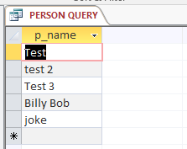

* + - List all of the fields from the appointment table  
      *That’s just the normal appointment table.*
    - List the names of all the services that cost more than 100 dollars  
      Access SQL Code:  
      SELECT service.s_name

FROM service

WHERE (((service.s_costperunit)>100));  
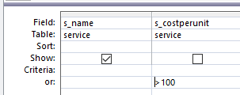

* + Code, test and save an Access form as per this storyboard:
    - 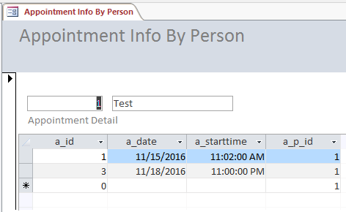
* **Recommendation:**
  + Please accept the demonstration as evidence of the per-specification functionality of the data entry application.